OUTPUT SCREEN SHOTS WITH DESCRIPTION.

Home Page:
Here user view the home page of Performance Analysis of Intrusion Detection Systems Using a Feature Selection Method web appellation.


Fig2: Home Page

About:
In the about page, users can learn more about Performance Analysis of Intrusion Detection Systems Using a Feature Selection Method.

Fig3: About

Login:
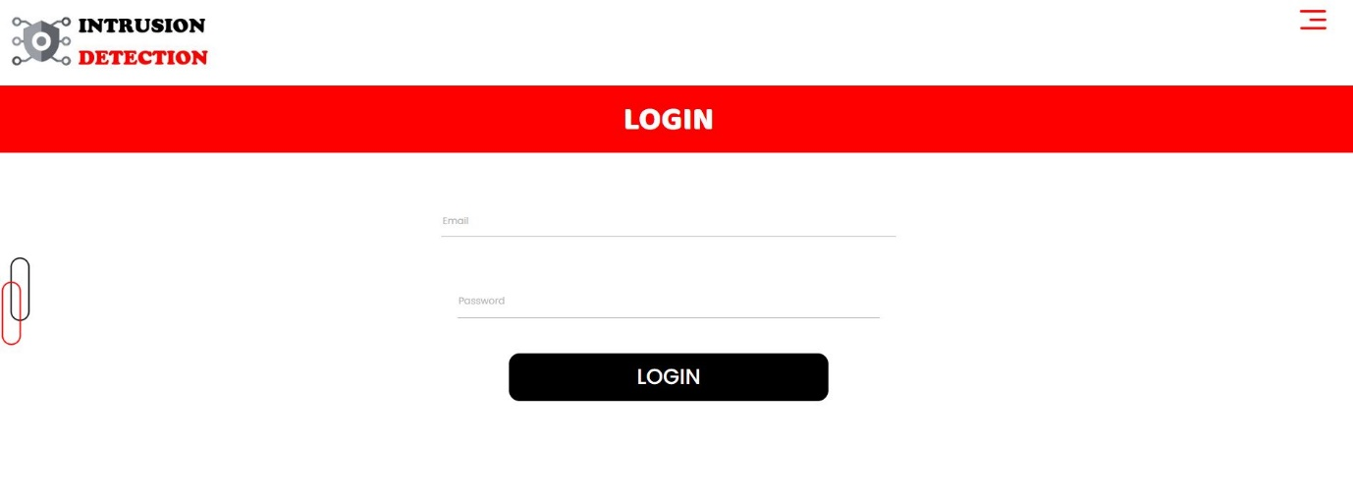
Fig4: Login.

Registration:
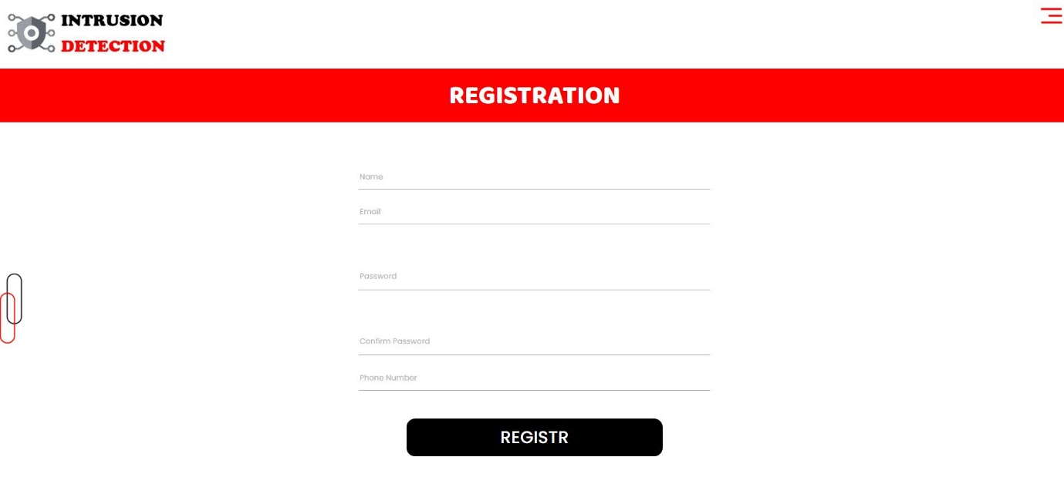
Fig5: Registration.

User Home Page:


Fig6: User Home page.

Upload Data Set:
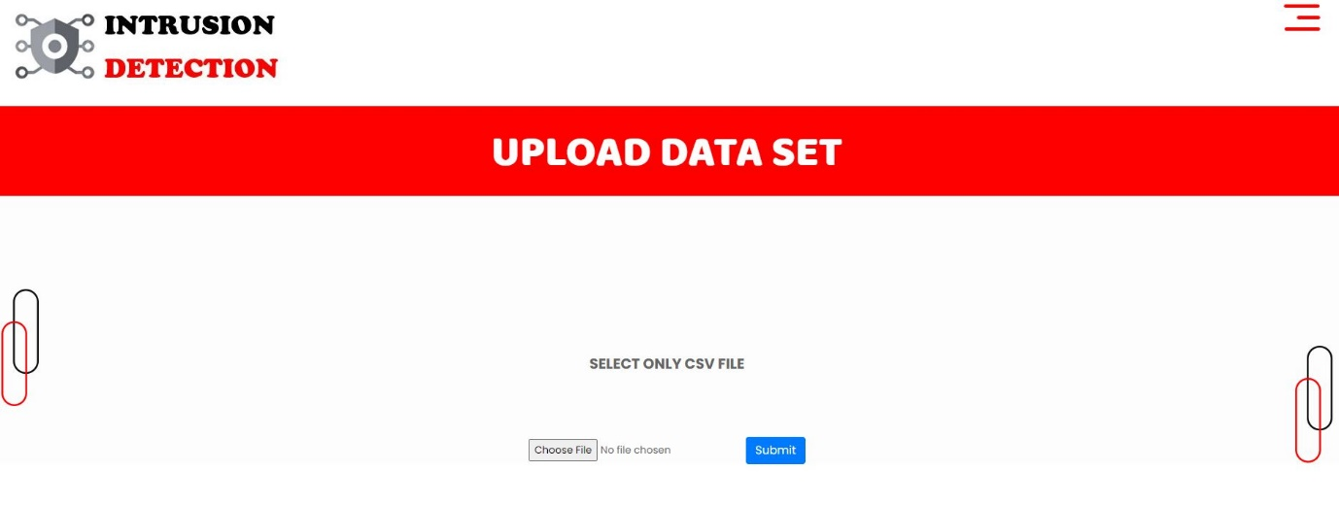

Fig7: Upload dataset.

View:
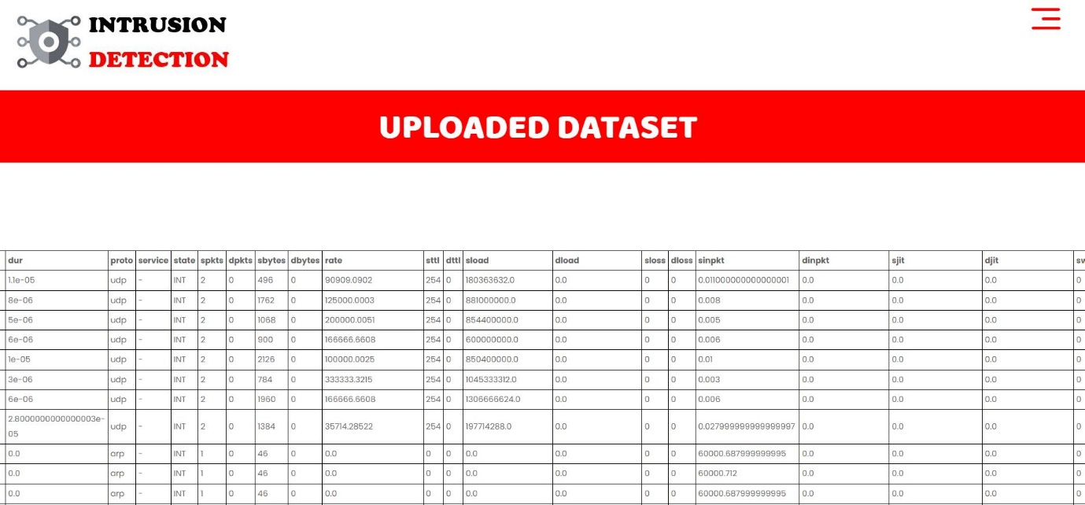

Fig8: View.

Preprocessing:
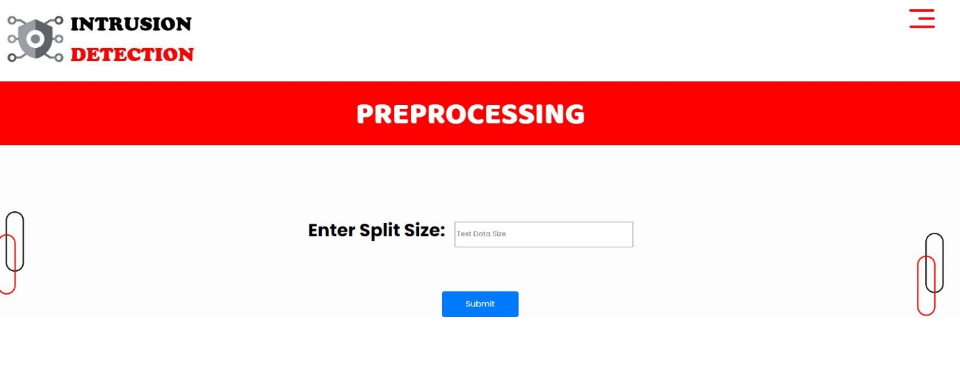

Fig9: Preprocessing

Training:
We’re training the algorithm to see which one has the best accuracy.
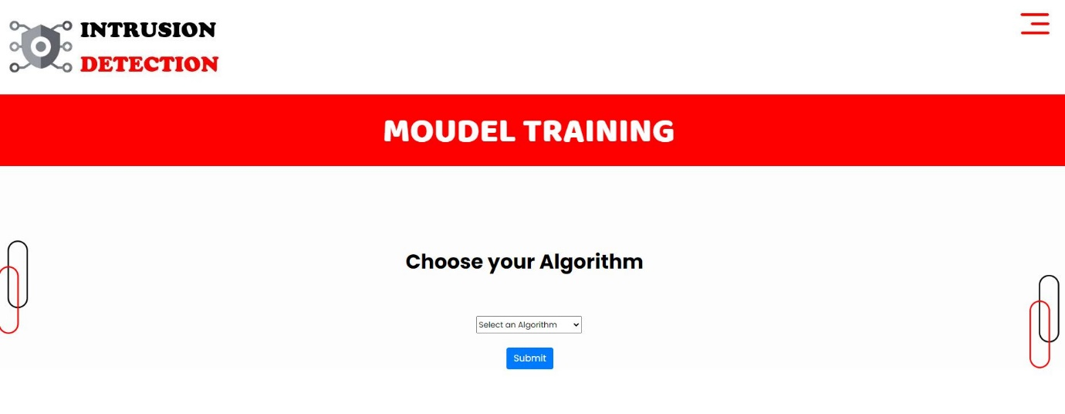
Fig10: Training Algorithm
Prediction:
This page show Performance Analysis of Intrusion Detection Systems Using a Feature Selection Method will predict Normal are attack.
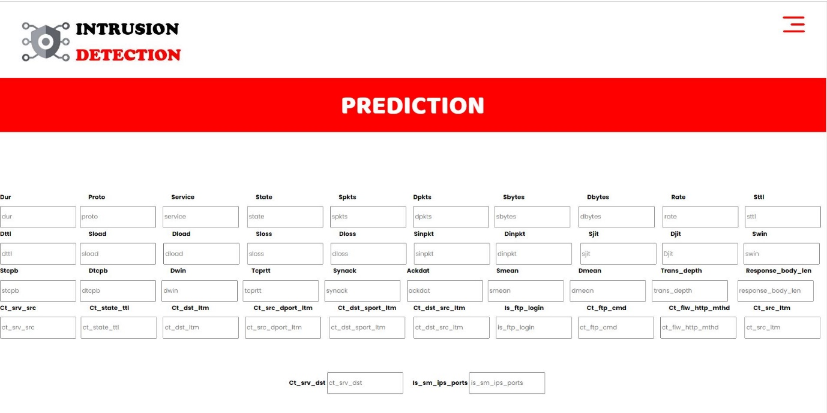

Fig11: Prediction
Graph:
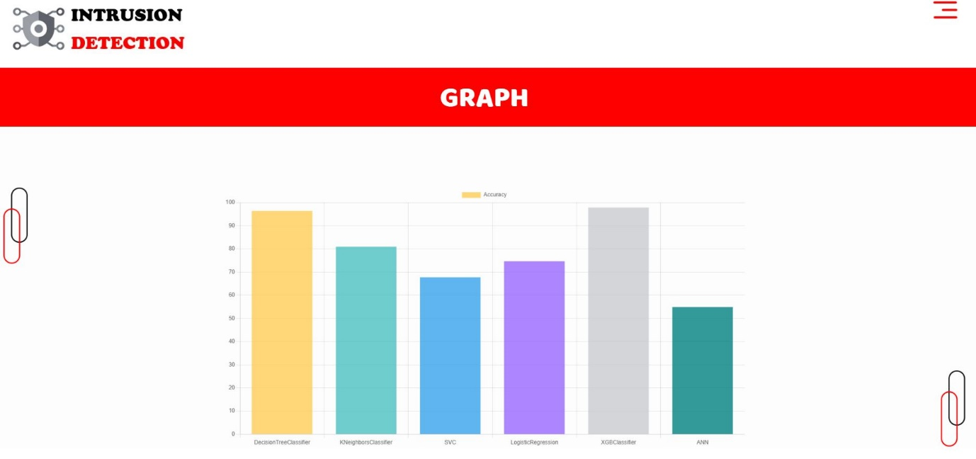

Fig12: Graph.

